**Games Market Research**

# Basic Market Analysis

## Current Platforms

Sony - PlayStation 4[1][2][3][4]

* 106 million units sold
* 5 million VR units sold
* 1.15 billion PlayStation 4 games sold
* 103 million active users
* 38.8 million PS Plus subscribers

Microsoft - Xbox One[5][6]

* 46 million units sold
* 64 million active users

Nintendo - Switch[7][8]

* 50 million units
* 15 million online subscribers

## Current Games

### Steam

Top Selling Steam Games in:

|  |  |  |
| --- | --- | --- |
| ***2017***[9] | ***2018***[10] | ***2019***[11] |
| Ghost Recon: Wildlands | PUBG | Dota 2 |
| The Witcher 3: Wild Hunt | Rainbow Six Siege | Warframe |
| H1Z1 Battle Royal | Assassin’s Creed: Odyssey | Monster Hunter World |
| Divinity II: Original Sin | Civilization VI | CS:GO |
| Rocket League | The Elder Scrolls Online | PUBG |
| CS:GO | Warframe | Total War: Three Kingdoms |
| Warframe | Dota 2 | Grand Theft Auto V |
| Rainbow Six Siege | Grand Theft Auto V | Rainbow Six Siege |
| Dota 2 | Monster Hunter World | Civilization VI |
| ARK: Survival Evolved | Rocket League | Sekiro: Shadows Die Twice |
| PUBG | Farcry 5 | The Elder Scrolls Online |
| Grand Theft Auto V | CS:GO | Destiny 2 |

Observations:

* 9/10 top selling games in 2018 and 2019, and 7/10 in 2017 are multiplayer focused games
* Games like GTA V, CS:GO, R6:S, Dota 2, and Warframe have been in all year’s best sellers (half of each list)
* Large amount of first person shooters

Conclusions:

* Multiplayer games are always in the top-sellers because the games are based around having large numbers of people playing at once
* People buy multiplayer games with friends or in groups which boosts the sales
* First person shooters are usually highly multiplayer which helps them get to the top

The top 10 Steam games by number of current players at 6PM AEST 16/4/2020[12]:

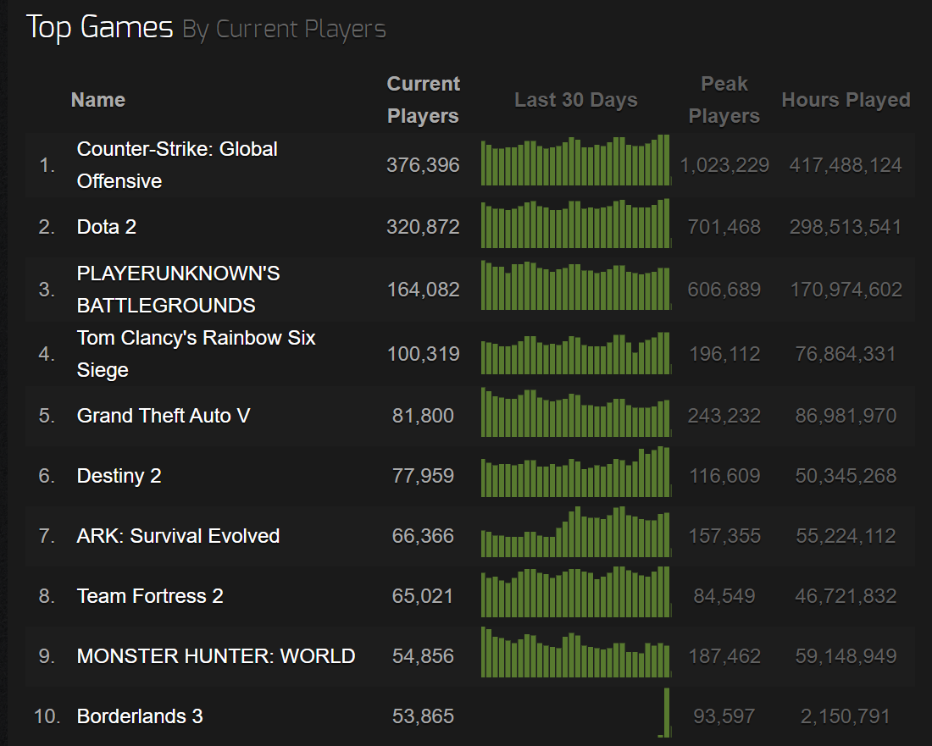

Observations:

* 8 out of 10 were in the best-selling of 2019
* Currently 4 out of the 10 most played games are free to play
* Borderland 3 was just released on Steam
  + Therefore, most owners are playing now
* Counter Strike: Global Offensive is number one
  + The game is 8 years old
  + Became free-to-play on 6/12/2018
  + Exclusive to Steam
* 5 out of 10 are competitive games

Conclusions:

* Steam is very accessible as two fifths of the top played games are free
* Players are drawn to Steam for exclusives like CS:GO and Dota 2

### PlayStation

Top 20 best-selling games for the PS4, compared to the PS3 and PS2.

|  |  |  |  |
| --- | --- | --- | --- |
|  | **PlayStation 2** | **PlayStation 3** | **PlayStation 4** |
| 1 | Grand Theft Auto: San Andreas (20.8M) | Grand Theft Auto V (20M) | Grand Theft Auto V (20M) |
| 2 | Grand Theft Auto: Vice City (16.1M) | Call of Duty: Black Ops II (13.8M) | Uncharted 4: A Thief's End (16M) |
| 3 | Gran Turismo 3 A-Spec (15M) | Call of Duty: Modern Warfare 3 (13.4M) | Call of Duty: Black Ops III (15.9M) |
| 4 | Grand Theft Auto III (13.1M) | Call of Duty: Black Ops (12.8M) | Red Dead Redemption 2 (14M) |
| 5 | Gran Turismo 4 (11.7M) | Gran Turismo 5 (12M) | Call of Duty: WWII (13.4M) |
| 6 | Final Fantasy X (8M) | Call of Duty: Modern warfare 2 (10.6M) | Marvel’s Spider-Man (13.2M) |
| 7 | Need for Speed: Underground (7.2M) | Grand Theft Auto IV (10.6M) | The Last of Us Remastered (11.8M) |
| 8 | Need for Speed: Underground 2 (6.9M) | Call of Duty Ghosts (10.1M) | FIFA 18 (11.8M) |
| 9 | Medal of Honor: Frontline (6.8M) | FIFA 13 (8M) | God of War (11M) |
| 10 | Kingdom Hearts (6.4M | Battlefield 3 (7.2M) | FIFA 17 (10.9M) |

|  |  |  |  |
| --- | --- | --- | --- |
|  | **PlayStation 2**[13][14] | **PlayStation 3**[15][16] | **PlayStation 4**[17][18] |
| 11 | Metal Gear Solid 2: Sons of Liberty (6M) | Uncharted 3: Drake’s Deception (6.8M) | Horizon Zero Dawn (10M) |
| 12 | Final Fantasy XII (6M) | Uncharted 2 (6.7M) | Call of Duty: Infinite Warfare (8.5M) |
| 13 | Crash Bandicoot: Wrath of Cortex (5.4M) | Call of Duty 4: Modern Warfare (6.7M) | Fallout 4 (8.4M) |
| 14 | Final Fantasy X-2 (5.3M) | FIFA 12 (6.6M) | FIFA 16 (8.2M) |
| 15 | Madden NFL 2004 (5.2M) | FIFA 14 (6.6M) | Star Wars: Battlefront (8M) |
| 16 | Dragon Quest VIII (5.2M) | Red Dead Redemption (6.6M) | Gran Turismo Sport (8M) |
| 17 | Medal of Honor: Rising Sun (5.1M) | Assassin’s Creed III (6.5M) | Call of Duty: Advanced Warfare (7.5M) |
| 18 | Guitar Hero II (5.1M) | Elder Scrolls V: Skyrim (6.5M) | Battlefield 1 (7.3M) |
| 19 | Guitar Hero III: Legends of Rock (5M) | The Last of Us (6.3M) | MineCraft (6.3M) |
| 20 | Madden NFL 06 (4.9M) | MineCraft (6M) | FIFA 15 (6.3M) |

Observations:

* The Grand Theft Auto series is always at the top of the charts
* On the PS2 there were more Japanese titles making the top sellers (6/20 compared to none on the latter 2 consoles)
* Madden was the most popular sports game on PS2, but for PS3 and PS4 the most popular is FIFA
* The PlayStation exclusives have better sales on PS4
* On the PS2 there was a larger variety of game genres
* Each iteration of the console gains game unit sales
* The PS2 did better in Asian markets whereas the latter 2 were more global
* Video game industry continues to grow

Conclusions:

* It’s a good time to be partnered with Sony as PlayStation exclusives increase in profitability
* Big name, open world RPGs are very successful currently so there would be a lot of competition for smaller developers
* Shooters and soccer games are always popular and make money

## Market Size

Top 10 countries by market size 2019[19]

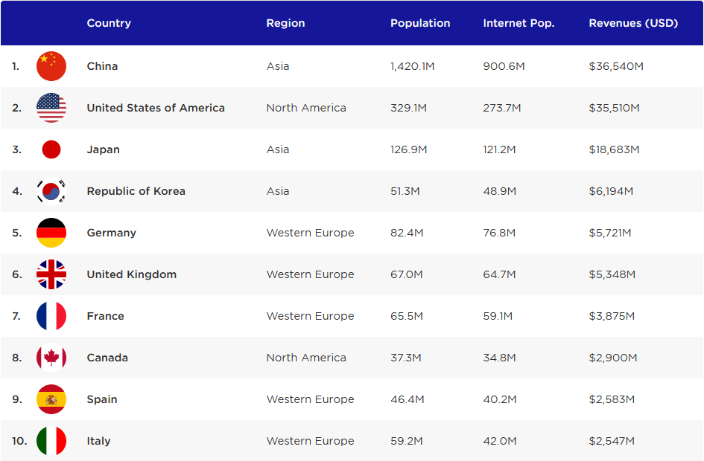

Observations:

* The USA is only slightly behind China in revenue despite China having a much larger population of internet users
* Japan has the largest population of internet users in relation to general population (95.5%)
* Only 3 of the top 10 are majority English speaking countries
* Either the population of USA spends more money on games or they have a higher amount of the population that spends money on games compared to China

Conclusions:

* It’s important for games to be localised as you will be missing out on a significant market share

# Non-Standard Markets

## Profile 1 – Chaos Theory[20]

Chaos Theory is a group that makes marketing games, applied games, and games for fun. They have worked with brands such as Samsung, eBay, Telstra, UTS, UNSW, and USyd.

### Products they have made:

* **Bleached AZ** – Arcade game with climate change awareness
* **M&M’s Take Home the Fun** – AR brand activation
* **Cups of Kings** – Party game
* **Elanation** – Sports app with video tutorials
* **Owls and Vowels** – Word puzzle game
* **Winter Wayfinder** – Winter VR experience
* **Rash Decisions** – Gamifying dermatology
* **Kick for Cash VR** – Virtual reality brand activation
* **eBay VR** – Virtual reality department store
* **In Their Shoes** – Helps pharmaceutical employees build empathy
* **Snakes the Game** – Re-imagining of classic game for product launch
* **Mass Mutations** – Engaging kids with STEM

Business Model: Contractor

### Utilisation:

* Increase brand activation/engagement through interactive experiences
* Make education fun through gamification
* Inform public about real world issues

### Additional Requirements:

* Web and app development knowledge
* Data collection skills
* Marketing expertise
* VR knowledge

## Profile 2 – Millipede[21]

### Products/Services:

* Motu Ta’e’iloa (Our Special Island) – Encouraging healthy eating in South Pacific
* ELLA – Early learning languages Australia
* Dumb Ways to Die 2 – Sequel to award winning game
* Dumb Ways Jr – Play-based learning game
* Run That Town – Game that uses real Australian census data
* Boost Juice Free the Fruit – Brand engagement
* Healthcare Heroes – Team based gamified corporate learning

### Business Model: Contractor

### Utilisation:

* Increase learning experience through educational gameplay
* Bring awareness to social issues
* Change behaviours through immersive messages

### Additional Requirements:

* Brand engagement marketing
* Information gathering
* Teaching skills

## Profile 3 – Mode[22]

### Products/Services:

* **Second Chances** – Educational game
* **Disney XD Oz Apocalypse** – Turned based game
* **Optus Speed of Bolt** – Endless runner brand promotion
* **Westpac Little Ripper** – Drone delivery marketing game
* **Pfizer VR Experiences** – Product explanation experience
* **Lilly Road Ahead Challenge** – Interactive conversation starter
* **Kinect Aspen Challenge** – Interactive product promotion
* **UNSW Engineering Physics** – Short educational game
* **Super Pals Battle Arena** – Port of web game to mobile
* **iD Gum Artcade** – Arcade and art gallery
* **ABC Artmaker and Playtime** – Localisation of app for Chinese market

### Business Model: Contractor

### Utilisation:

* Make education more interesting
* Explain new products through short games experiences
* Increase brand awareness

### Additional Requirements:

* Marketing
* QA testing
* Analytics tracking
* VR knowledge

# Social Issues in Game Market

## Violence

## Diversity

### Persona 5

### Catherine: Full Body

## Health Issues & Addiction

## Games for Good

### Nintendo Ring Fit Adventure

* Exercise games prove to be successful
  + Ring Fit Adventure is highly popular with 650,000 sales in only 5 months[23]
  + Nintendo also made Wii Fit which had 43.8 million sales[24]
  + Just like Wii Fit, Ring Fit sold out quickly and had to re-stock
* Exercise games are effective
  + The game motivates those who stay and home and find exercise boring
  + It proves that exercise through gamification helps people lose weight[25]
  + Good for times of social isolation where home exercise is popular

1. [[The PlayStation 4 is now the second best-selling home console of all time, with over 102 million sold](https://www.businessinsider.com.au/sony-ps4-lifetime-sales-top-100-million-2019-7?r=US&IR=T)](https://www.businessinsider.com.au/sony-ps4-lifetime-sales-top-100-million-2019-7?r=US&IR=T%20) 
2. [The PS4 just became the second best-selling console of all time](https://thenextweb.com/gaming/2019/10/31/the-ps4-just-became-the-second-best-selling-console-of-all-time/)
3. [Supplemental Information for the Consolidated Financial Results for the Second Quarter Ended September 30, 2019](https://www.sony.net/SonyInfo/IR/library/presen/er/pdf/19q2_supplement.pdf)
4. [PlayStation 5 logo revealed as PS4 surpasses 106 million systems sold](https://venturebeat.com/2020/01/06/playstation-5-logo/)
5. [• Global Xbox One console unit sales 2020](https://www.statista.com/statistics/1005403/global-xbox-one-console-unit-sales/)
6. [Xbox Live Hits 64 Million Active Users](https://variety.com/2019/gaming/news/xbox-live-hits-64-million-active-users-1203124112/)
7. [Nintendo Switch unit sales worldwide 2020](https://www.statista.com/statistics/687059/nintendo-switch-unit-sales-worldwide/)
8. [Nintendo Switch Online tops 15 million subscribers](https://www.videogameschronicle.com/news/nintendo-switch-online-tops-15-million-subscribers/)
9. [The Top Sellers of 2017](https://store.steampowered.com/sale/2017_best_sellers/)
10. [The Top Sellers of 2018](https://store.steampowered.com/sale/winter2018bestof/)
11. [Best of 2019 - Top Sellers](https://store.steampowered.com/sale/2019_top_sellers)
12. [Top Games by Current Players](https://steamcharts.com/top)
13. [The top-selling PlayStation 2 games](https://www.vgchartz.com/platform/4/playstation-2/)
14. [List of best-selling PlayStation 2 video games](https://en.wikipedia.org/wiki/List_of_best-selling_PlayStation_2_video_games)
15. [The top-selling PlayStation 3 games](https://www.vgchartz.com/platform/3/playstation-3/)
16. [List of best-selling PlayStation 3 video games](https://en.wikipedia.org/wiki/List_of_best-selling_PlayStation_3_video_games)
17. [The top-selling PlayStation 4 games](https://www.vgchartz.com/platform/69/playstation-4/)
18. [List of best-selling PlayStation 4 video games](https://en.wikipedia.org/wiki/List_of_best-selling_PlayStation_4_video_games)
19. [Top Countries & Markets by Game Revenues](https://newzoo.com/insights/rankings/top-10-countries-by-game-revenues/)
20. <https://www.chaostheorygames.com/>
21. <https://millipede.com.au/index.html>
22. <https://mode-games.com/>
23. [This Week in Sales: Ring Fit Adventure Charts #1 After 16 Weeks](https://www.siliconera.com/this-week-in-sales-survival-of-the-ring-fittest/)
24. [Nintendo Wii top selling games worldwide 2019](https://www.statista.com/statistics/248204/top-selling-nintendo-wii-titles-worldwide/)
25. [Ring Fit Adventure Player Shows Off His Healthy Transformation After One Month](http://www.nintendolife.com/news/2020/01/ring_fit_adventure_player_shows_off_his_healthy_transformation_after_one_month)